General Linear Model:

1. What is the purpose of the General Linear Model (GLM)?

Ans:- The purpose of the General Linear Model (GLM) is to analyze relationships between a dependent variable and one or more independent variables, allowing for estimation and testing of various types of linear models.

1. What are the key assumptions of the General Linear Model?

Ans:- The key assumptions of the General Linear Model (GLM) include:

1. Linearity: The relationship between the dependent variable and the independent variables is assumed to be linear.
2. Independence: Observations are assumed to be independent of each other.
3. Normality: The residuals (the differences between observed and predicted values) are assumed to be normally distributed.
4. Homoscedasticity: The variance of the residuals is assumed to be constant across all levels of the independent variables.
5. No multicollinearity: The independent variables should not be highly correlated with each other.
6. No influential outliers: The presence of influential outliers can affect the parameter estimates and model fit.

These assumptions should be assessed and, if violated, appropriate corrective measures or alternative models may be necessary.

1. How do you interpret the coefficients in a GLM?

Ans:- The coefficients in a General Linear Model (GLM) represent the estimated effect or association between the independent variables and the dependent variable. The interpretation of the coefficients depends on the specific variables and model used, but generally, they indicate the change in the dependent variable associated with a one-unit change in the corresponding independent variable, while holding other variables constant.

1. What is the difference between a univariate and multivariate GLM?

Ans:- The difference between a univariate and multivariate General Linear Model (GLM) lies in the number of dependent variables being analyzed.

1. Univariate GLM: In a univariate GLM, there is only one dependent variable being analyzed. The model focuses on understanding the relationship between this single dependent variable and one or more independent variables. It allows for the examination of the effect of independent variables on a single outcome variable.
2. Multivariate GLM: In a multivariate GLM, there are multiple dependent variables being analyzed simultaneously. The model explores the relationships between these multiple dependent variables and one or more independent variables. It allows for the examination of the interrelationships among the dependent variables and how they are influenced by the independent variables.

In summary, a univariate GLM analyzes the relationship between one dependent variable and independent variables, while a multivariate GLM analyzes the relationships among multiple dependent variables and independent variables.

1. Explain the concept of interaction effects in a GLM.

Ans Interaction effects in a GLM refer to the situation where the relationship between the dependent variable and one independent variable depends on the levels or values of another independent variable. It means that the effect of one variable on the dependent variable changes based on the presence or absence of another variable.

1. How do you handle categorical predictors in a GLM?

Ans:- To handle categorical predictors in a GLM, one common approach is to convert them into dummy variables. This involves creating separate binary variables for each category or level of the categorical predictor. Each binary variable represents the presence or absence of a specific category, and these variables are then included as predictors in the GLM. This allows the model to capture the effects of different categories of the categorical predictor on the dependent variable.

1. What is the purpose of the design matrix in a GLM?

Ans:- The purpose of the design matrix in a GLM is to organize and represent the predictor variables used in the model. It is a matrix that contains the values of the predictors and is essential for estimating the regression coefficients and making predictions.

1. How do you test the significance of predictors in a GLM?

Ans:- To test the significance of predictors in a GLM, statistical tests such as t-tests or F-tests are used. These tests compare the estimated coefficients of the predictors to their null hypothesis values and calculate a p-value. A small p-value (typically below a predetermined significance level like 0.05) indicates that the predictor is significant, while a larger p-value suggests that the predictor is not significant.

1. What is the difference between Type I, Type II, and Type III sums of squares in a GLM?

Ans:- Type I sums of squares sequentially add predictor variables to the model, assessing their unique contribution while controlling for previously entered variables.

Type II sums of squares assess the unique contribution of each predictor variable while adjusting for all other variables in the model, independent of the order of entry.

Type III sums of squares assess the unique contribution of each predictor variable while accounting for the effects of all other variables, including interactions, in the model.

1. Explain the concept of deviance in a GLM.

Ans:- Deviance in a GLM measures the discrepancy between the observed data and the model's predictions. It quantifies how well the model fits the data and is used for model comparison and hypothesis testing. A smaller deviance indicates a better fit to the data.

Regression:

1. What is regression analysis and what is its purpose?

Ans:- Regression analysis is a statistical technique used to analyze the relationship between a dependent variable and one or more independent variables. Its purpose is to understand how changes in the independent variables are associated with changes in the dependent variable, to make predictions, and to assess the significance and strength of these relationships.

1. What is the difference between simple linear regression and multiple linear regression?

Ans:- The difference between simple linear regression and multiple linear regression lies in the number of independent variables being considered.

1. Simple Linear Regression: In simple linear regression, there is one independent variable used to predict a dependent variable. The relationship between the independent and dependent variable is assumed to be linear, and the goal is to estimate the slope and intercept of the regression line that best fits the data.
2. Multiple Linear Regression: In multiple linear regression, there are two or more independent variables used to predict a dependent variable. The relationship between the independent variables and the dependent variable is assumed to be linear, and the goal is to estimate the coefficients of the regression equation that best fits the data.
3. How do you interpret the R-squared value in regression?

Ans:- The R-squared value in regression represents how well the independent variables explain the variation in the dependent variable. A higher R-squared value indicates a better fit, meaning that a larger proportion of the variation in the dependent variable is accounted for by the independent variables.

1. What is the difference between correlation and regression?

* Ans:- Correlation measures the strength of the linear relationship between two variables. It does not tell us *how* one variable affects the other, just that there is some kind of relationship.
* Regression expresses the relationship between two variables in the form of an equation. This equation can be used to predict the value of one variable based on the value of the other variable.

correlation tells us **whether** there is a relationship between two variables, while regression tells us **how** the variables are related.

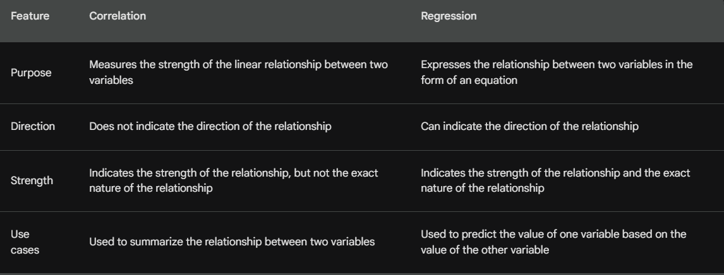

1. What is the difference between the coefficients and the intercept in regression?

* Ans:- Coefficients are the numbers that multiply the independent variables in a regression equation. They represent the *slope* of the line, or how much the dependent variable changes for a one-unit change in the independent variable.
* Intercept is the value of the dependent variable when all of the independent variables are equal to zero. It represents the *y-intercept* of the line, or the value of the dependent variable when there is no change in the independent variables.

the coefficients tell us how much the dependent variable changes as the independent variables change, while the intercept tells us the value of the dependent variable when the independent variables are all zero.

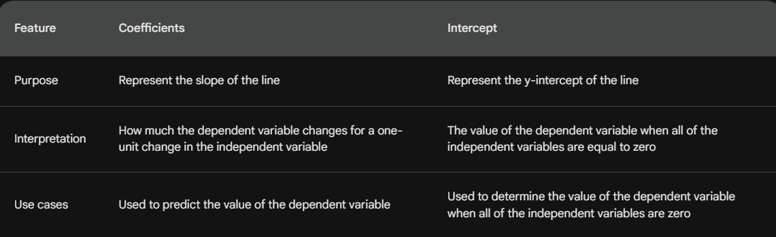

1. How do you handle outliers in regression analysis?

* Ans:- Deleting the outliers. This is the most straightforward approach, but it can also be the most drastic. If the outliers are due to data entry errors or measurement errors, then deleting them may be the best option. However, if the outliers are legitimate data points, then deleting them could bias the results of the analysis.
* Treating the outliers. This involves transforming the data in some way to reduce the impact of the outliers. Common transformations include taking the logarithm, square root, or reciprocal of the data. These transformations can help make the data more normally distributed and stabilize the variance.
* Using robust regression methods. Robust regression methods are designed to be less sensitive to outliers than traditional regression methods. These methods can be used to fit a regression model that is not as affected by the outliers.

1. What is the difference between ridge regression and ordinary least squares regression?

* Ans:-Ordinary least squares regression (OLS) is a method for fitting a linear regression model to data. It minimizes the sum of squared residuals, which are the differences between the observed values and the predicted values of the dependent variable.
* Ridge regression is a type of regularization that adds a penalty to the OLS objective function. This penalty penalizes large coefficients, which can help to prevent overfitting.

OLS regression minimizes the error between the predicted and observed values, while ridge regression minimizes the error while also penalizing large coefficients.

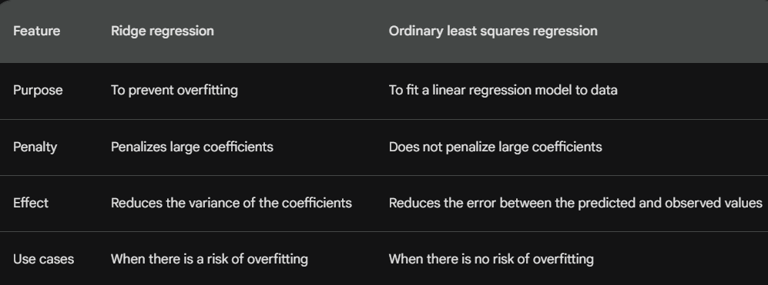

1. What is heteroscedasticity in regression and how does it affect the model?

Ans:- Heteroscedasticity is a statistical phenomenon in which the variance of the error term in a regression model is not constant. This means that the residuals are not evenly distributed around the regression line, but rather, they are spread out more in some areas than in others.

* Heteroscedasticity can affect the model in a number of ways. First, it can make the standard errors of the coefficients inaccurate. This means that the confidence intervals for the coefficients may be too narrow or too wide, which can lead to incorrect inferences. Second, heteroscedasticity can make the t-tests for the coefficients less powerful. This means that it may be more difficult to reject the null hypothesis, even when the true coefficients are significantly different from zero.

1. How do you handle multicollinearity in regression analysis?

Ans:- Multicollinearity is a statistical phenomenon in which two or more independent variables in a regression model are highly correlated. This can cause problems with the model, such as making the standard errors of the coefficients inaccurate and making it difficult to interpret the results.

There are a number of ways to handle multicollinearity in regression analysis.

* Remove one or more of the correlated variables. This is the most common approach, but it can be difficult to decide which variables to remove.
* Center the variables. This involves subtracting the mean from each variable before fitting the model. This can help to reduce the correlation between the variables.
* Use a different regression method. Some regression methods, such as ridge regression and lasso regression, are designed to handle multicollinearity.
* Do nothing. In some cases, multicollinearity may not have a significant impact on the model. If the model is still accurate and interpretable, then there may be no need to do anything

1. What is polynomial regression and when is it used?

Ans:- Polynomial regression is a type of regression analysis that uses a polynomial function to model the relationship between the independent and dependent variables.

* Polynomial regression is used when the relationship between the independent and dependent variables is not linear. For example, if the relationship is curvilinear, then a polynomial regression model can be used to fit a curve to the data.

Loss function:

1. What is a loss function and what is its purpose in machine learning?

* Ans:- A loss function is a mathematical function that measures the difference between the predicted values and the actual values.
* The purpose of a loss function is to quantify the error of a machine learning model.
* The loss function is used to train the model by minimizing the error.

1. What is the difference between a convex and non-convex loss function?

* Ans:-Convex loss functions have a single minimum point, which means that there is a unique solution to the optimization problem.
* Non-convex loss functions have multiple minimum points, which means that there may be multiple solutions to the optimization problem.

Convex loss functions are easier to optimize than non-convex loss functions. This is because there is a single direction in which the loss function decreases, so the optimization algorithm can always move in the direction of the minimum point.

Non-convex loss functions can be more difficult to optimize because there may be multiple directions in which the loss function decreases. This can make it difficult for the optimization algorithm to find the global minimum point.

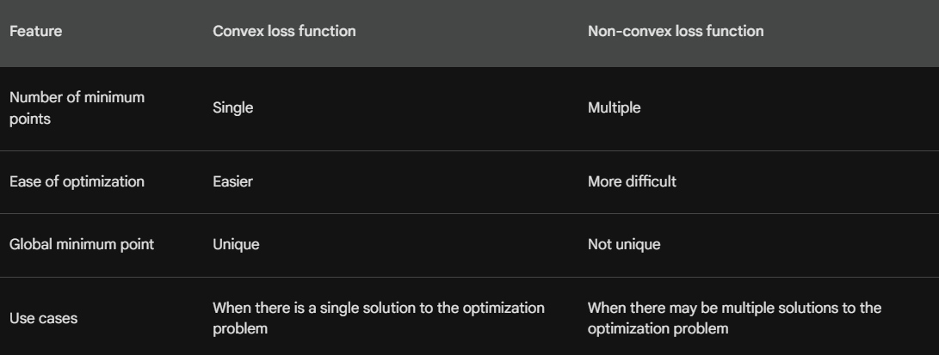

1. What is mean squared error (MSE) and how is it calculated?

Ans:- **Mean squared error (MSE)** is a measure of the average squared difference between the predicted values and the actual values. It is a common metric used in regression analysis to evaluate the accuracy of a model.

MSE = Σ(yi - pi)^2 / n

* yi is the actual value for the ith observation
* pi is the predicted value for the ith observation
* n is the number of observations

1. What is mean absolute error (MAE) and how is it calculated?

Ans:- Mean absolute error (MAE) is a measure of the average absolute difference between the predicted values and the actual values. It is a common metric used in regression analysis to evaluate the accuracy of a model.

MAE = Σ|yi - pi| / n

* yi is the actual value for the ith observation
* pi is the predicted value for the ith observation
* n is the number of observations

MAE is calculated by taking the absolute difference between the predicted values and the actual values, then averaging the absolute differences. The lower the MAE, the better the model is performing.

1. What is log loss (cross-entropy loss) and how is it calculated?

Ans:- **Log loss**, also known as **cross-entropy loss**, is a measure of the difference between the predicted probabilities and the actual probabilities. It is a common metric used in classification problems to evaluate the accuracy of a model.

log loss = −∑yi log(pi) + (1 − yi) log(1 − pi)

* yi is the actual class label for the ith observation
* pi is the predicted probability for the ith observation
* n is the number of observations

Log loss is calculated by taking the logarithm of the predicted probabilities for the actual class labels, then summing the logarithms. The lower the log loss, the better the model is performing.

1. How do you choose the appropriate loss function for a given problem?

Ans:- The choice of loss function depends on the type of problem that you are trying to solve. Here are some factors to consider when choosing a loss function:

* **The type of problem:** If you are trying to solve a regression problem, then you will need to choose a loss function that measures the difference between the predicted values and the actual values. If you are trying to solve a classification problem, then you will need to choose a loss function that measures the difference between the predicted probabilities and the actual probabilities.
* **The distribution of the data:** If the data is normally distributed, then you can use MSE or MAE. If the data is not normally distributed, then you may need to use a different loss function, such as Huber loss or quantile loss.
* **The sensitivity to outliers:** If the data contains outliers, then you will need to choose a loss function that is not sensitive to outliers. For example, MAE is not sensitive to outliers, while MSE is sensitive to outliers.

1. Explain the concept of regularization in the context of loss functions.

Ans:- Regularization is a technique used to prevent overfitting in machine learning models. Overfitting occurs when a model learns the training data too well and is unable to generalize to new data. Regularization adds a penalty to the loss function that discourages the model from becoming too complex. This can help to prevent the model from overfitting the training data.

There are two main types of regularization: **L1 regularization** and **L2 regularization**. L1 regularization penalizes the absolute values of the coefficients in the model. This can help to simplify the model and make it more interpretable. L2 regularization penalizes the squares of the coefficients in the model. This can help to prevent the model from becoming too complex and improve its generalization performance.

1. What is Huber loss and how does it handle outliers?

Ans:- Huber loss is a loss function that is less sensitive to outliers than MSE. It is a combination of MSE and absolute loss. Huber loss is calculated as follows:

Huber loss = |xi - yi|^2 / 2σ^2 if |xi - yi| < σ

+ σ^2 (xi - yi) / 2 if |xi - yi| ≥ σ

where:

* xi is the predicted value for the ith observation
* yi is the actual value for the ith observation
* σ is a hyperparameter that controls the degree of robustness to outliers

If the difference between the predicted value and the actual value is less than σ, then Huber loss is equal to the squared difference divided by 2σ^2. This is similar to MSE. However, if the difference between the predicted value and the actual value is greater than σ, then Huber loss is equal to σ^2 times the difference between the predicted value and the actual value divided by 2. This is similar to absolute loss.

Huber loss is a good choice for regression problems that contain outliers. It is less sensitive to outliers than MSE, which means that it is less likely to be affected by outliers.

1. What is quantile loss and when is it used?

Ans:-Quantile loss is a loss function that measures the difference between the predicted quantiles and the actual quantiles. It is a good choice for regression problems where you want to predict the quantiles of the target variable.

Quantile loss is calculated as follows:

Quantile loss = |F(xi) - yi|^2 where F is the cumulative distribution function of the predicted quantiles

where:

* xi is the predicted value for the ith observation
* yi is the actual value for the ith observation
* F is the cumulative distribution function of the predicted quantiles

Quantile loss is a non-convex loss function, which means that it can be difficult to optimize. However, it is a good choice for regression problems where you want to predict the quantiles of the target variable.

Here are some of the benefits of using quantile loss:

* Robust to outliers: Quantile loss is more robust to outliers than MSE. This is because it only penalizes the errors that are larger than the quantiles.
* Flexible: Quantile loss can be used to predict any quantile of the target variable. This makes it a versatile loss function for regression problems.

1. What is the difference between squared loss and absolute loss?

Ans:- **Squared loss** and **absolute loss** are two different loss functions that are used in machine learning. They are both used to measure the error between the predicted values and the actual values. However, they have different properties and are used in different situations.

**Squared loss** is calculated as the squared difference between the predicted values and the actual values. It is a **convex** function, which means that it has a single minimum point. This makes it easy to optimize. However, it is **sensitive to outliers**, which means that it can be heavily influenced by a few very large errors.

**Absolute loss** is calculated as the absolute difference between the predicted values and the actual values. It is a **non-convex** function, which means that it has multiple minimum points. This makes it more difficult to optimize. However, it is **robust to outliers**, which means that it is not as heavily influenced by a few very large errors.

Optimizer (GD):

1. What is an optimizer and what is its purpose in machine learning?

Ans:-   
Sure, here is an answer on what an optimizer is and what is its purpose in machine learning:

An optimizer is a function that updates the parameters of a machine learning model in order to minimize a loss function. The loss function measures the error between the predicted values and the actual values. The optimizer tries to find the parameters that minimize the loss function, which means that the model will make better predictions.

the most common optimizers used in machine learning:

* Gradient descent: Gradient descent is the most common optimizer. It works by iteratively updating the parameters in the direction of the negative gradient of the loss function.
* Stochastic gradient descent: Stochastic gradient descent is a variant of gradient descent that updates the parameters using a subset of the data. This makes it more efficient than gradient descent, but it may not converge as quickly.
* Adagrad: Adagrad is an optimizer that adapts the learning rate to the parameters of the model. This means that the parameters that are updated more frequently are updated less aggressively.
* RMSprop: RMSprop is an optimizer that is similar to Adagrad, but it uses a moving average of the gradients to calculate the learning rate. This makes it more stable than Adagrad.
* Adam: Adam is a newer optimizer that combines the advantages of Adagrad and RMSprop. It is a very popular optimizer for deep learning models.

1. What is Gradient Descent (GD) and how does it work?

Ans:- Gradient descent (GD) is an iterative optimization algorithm for finding the minimum of a function. It works by starting with an initial guess for the minimum and then iteratively updating the guess in the direction of the negative gradient of the function. The gradient of a function is a vector that points in the direction of the steepest ascent of the function. The negative gradient points in the direction of the steepest descent.

let's say we want to find the minimum of the function f(x) = x^2. The gradient of f(x) is 2x. So, we start with an initial guess for x, say x = 0. Then, we update x by subtracting 2x from it, which gives us x = -2. We repeat this process until the gradient of f(x) is close to zero.

In machine learning, gradient descent is used to train machine learning models. The loss function of the model is minimized using gradient descent. The loss function measures the error between the predicted values and the actual values. The goal of gradient descent is to find the parameters of the model that minimize the loss function.

Here are some of the benefits of using gradient descent:

* It is a simple and efficient algorithm.
* It is easy to implement.
* It is widely used in machine learning.

1. What are the different variations of Gradient Descent?

* Ans:-Batch gradient descent: This is the simplest version of gradient descent. It uses the entire dataset to calculate the gradient at each step. This can be slow for large datasets.
* Stochastic gradient descent: This is a variant of gradient descent that uses a single data point to calculate the gradient at each step. This makes it more efficient for large datasets, but it may not converge as quickly.
* Mini-batch gradient descent: This is a compromise between batch gradient descent and stochastic gradient descent. It uses a small batch of data points to calculate the gradient at each step. This makes it more efficient than batch gradient descent, but it may not converge as quickly as stochastic gradient descent.
* Momentum: Momentum is a technique that can be used to improve the convergence of gradient descent. It works by adding a fraction of the previous update to the current update. This helps to prevent the algorithm from getting stuck in local minima.
* Adagrad: Adagrad is an adaptive learning rate method that can be used with gradient descent. It works by adjusting the learning rate based on the magnitude of the gradients. This helps to prevent the algorithm from getting stuck in areas of the loss function with large gradients.
* RMSprop: RMSprop is another adaptive learning rate method that can be used with gradient descent. It works by taking a moving average of the squared gradients and using that to calculate the learning rate. This helps to make the algorithm more stable.
* Adam: Adam is a newer optimizer that combines the advantages of Adagrad and RMSprop. It is a very popular optimizer for deep learning models.

1. What is the learning rate in GD and how do you choose an appropriate value?

Ans:- The learning rate in gradient descent (GD) is a hyperparameter that controls how much the model parameters are updated at each step. A higher learning rate will cause the model to update more quickly, while a lower learning rate will cause the model to update more slowly.

The choice of learning rate is important because it can affect the convergence of the algorithm. If the learning rate is too high, the algorithm may not converge or may converge to a suboptimal solution. If the learning rate is too low, the algorithm may converge very slowly.

* Start with a high learning rate and then gradually decrease it.
* Use a technique called learning rate decay to gradually decrease the learning rate over time.
* Try different learning rates and see what works best for your problem.
* Be patient and allow the algorithm to converge.

1. How does GD handle local optima in optimization problems?

Ans:- Gradient descent (GD) is an iterative optimization algorithm that works by moving towards the direction of the steepest descent of a loss function. This means that GD is always moving towards the minimum of the loss function, but it can get stuck in local minima.

A local minimum is a point in the loss function where the gradient is zero. This means that GD will stop moving if it reaches a local minimum. However, the local minimum may not be the global minimum of the loss function.

handling local optima in GD:

* Use stochastic gradient descent with momentum.
* Try different learning rates and hyperparameters.
* Be patient and allow the algorithm to converge.

1. What is Stochastic Gradient Descent (SGD) and how does it differ from GD?

Ans:- Stochastic gradient descent (SGD) is a variant of gradient descent that uses a single data point to calculate the gradient at each step. This makes it more efficient for large datasets, but it may not converge as quickly.

Gradient descent, on the other hand, uses the entire dataset to calculate the gradient at each step. This can be slow for large datasets, but it may converge more quickly.

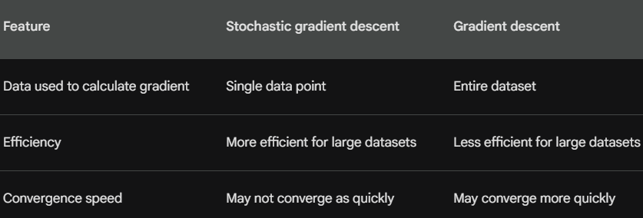

benefits of using SGD:

* It is more efficient for large datasets.
* It is less sensitive to noise in the data.
* It is easier to implement.

SGD also has some limitations:

* It may not converge as quickly as gradient descent.
* It can be more difficult to tune the hyperparameters.
* It can be more prone to overfitting.

1. Explain the concept of batch size in GD and its impact on training.

Ans:- The **batch size** in gradient descent (GD) is the number of data points that are used to calculate the gradient at each step. A larger batch size will make the gradient more accurate, but it will also make the algorithm slower. A smaller batch size will make the algorithm faster, but it may not be as accurate.

The choice of batch size depends on the specific problem that you are trying to solve. If you are working with a large dataset, then a larger batch size may be a good choice. If you are working with a small dataset, then a smaller batch size may be a better choice.

1. What is the role of momentum in optimization algorithms?

Ans:- Momentum is a technique that can be used to improve the convergence of gradient descent algorithms. It works by adding a fraction of the previous update to the current update. This helps to prevent the algorithm from getting stuck in local minima.

In machine learning, gradient descent algorithms are used to train machine learning models. The loss function of the model is minimized using gradient descent. The loss function measures the error between the predicted values and the actual values. The goal of gradient descent is to find the parameters of the model that minimize the loss function.

he benefits of using momentum:

* It can help to improve the convergence of gradient descent algorithms.
* It can help to prevent gradient descent from getting stuck in local minima.
* It can be more efficient than gradient descent without momentum.

momentum also has some limitations:

* It can be more difficult to tune the hyperparameters.
* It can make the algorithm more sensitive to noise in the data.

1. What is the difference between batch GD, mini-batch GD, and SGD?

Ans:- Batch gradient descent (BGD), mini-batch gradient descent (MBGD), and stochastic gradient descent (SGD) are all gradient descent algorithms that are used to train machine learning models. However, they differ in the way that they calculate the gradient.

* Batch gradient descent uses the entire dataset to calculate the gradient at each step. This can be slow for large datasets, but it may converge more quickly.
* Mini-batch gradient descent uses a small subset of the dataset to calculate the gradient at each step. This makes it more efficient for large datasets, but it may not converge as quickly as batch gradient descent.
* Stochastic gradient descent uses a single data point to calculate the gradient at each step. This makes it the most efficient for large datasets, but it may not converge as quickly as batch gradient descent or mini-batch gradient descent.

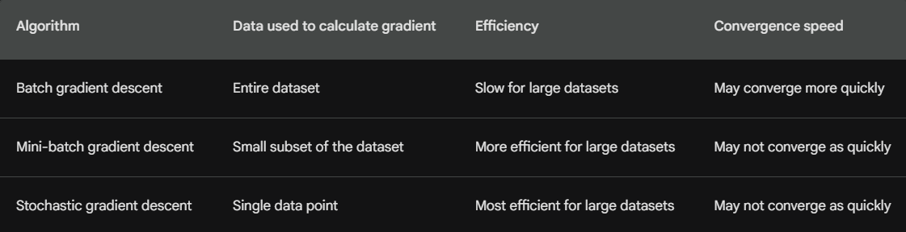

the benefits and drawbacks of each algorithm:

* Batch gradient descent:
  + Benefit: May converge more quickly
  + Drawback: Slow for large datasets
* Mini-batch gradient descent:
  + Benefit: More efficient for large datasets
  + Drawback: May not converge as quickly as BGD
* Stochastic gradient descent:
  + Benefit: Most efficient for large datasets
  + Drawback: May not converge as quickly as BGD or MBGD

1. How does the learning rate affect the convergence of GD?

Ans:- The learning rate is a hyperparameter in gradient descent (GD) that controls how much the model parameters are updated at each step. A higher learning rate will cause the model to update more quickly, while a lower learning rate will cause the model to update more slowly.

The choice of learning rate is important because it can affect the convergence of the algorithm. If the learning rate is too high, the algorithm may not converge or may converge to a suboptimal solution. If the learning rate is too low, the algorithm may converge very slowly.

the factors to consider when choosing a learning rate:

* The size of the dataset: If you are working with a large dataset, then you may want to choose a lower learning rate. This is because a lower learning rate will help the algorithm to converge more smoothly.
* The noise in the data: If the data is noisy, then you may want to choose a lower learning rate. This is because a lower learning rate will help the algorithm to avoid getting stuck in local minima.
* The complexity of the model: If the model is complex, then you may want to choose a lower learning rate. This is because a lower learning rate will help the algorithm to avoid overfitting the data.

The choice of learning rate is a trade-off between convergence speed and the risk of overfitting. You need to choose a learning rate that is high enough to converge quickly, but not so high that it causes the model to overfit the data.

Regularization:

1. What is regularization and why is it used in machine learning?

Ans:- **Regularization** is a technique used to prevent machine learning models from overfitting the training data. Overfitting occurs when a model learns the training data too well and is unable to generalize to new data. Regularization adds a penalty to the loss function that discourages the model from becoming too complex. This helps to prevent the model from fitting the noise in the training data and makes it more likely to generalize to new data.

There are two main types of regularization: **L1 regularization** and **L2 regularization**. L1 regularization adds a penalty to the sum of the absolute values of the model coefficients. This encourages the model to have smaller coefficients, which makes it less complex. L2 regularization adds a penalty to the sum of the squared values of the model coefficients. This also encourages the model to have smaller coefficients, but it is less aggressive than L1 regularization.

Regularization is a powerful technique that can help to improve the performance of machine learning models. It is especially useful for models that are trained on small datasets or models that are prone to overfitting.

benefits of using regularization:

* Prevents overfitting: Regularization helps to prevent machine learning models from overfitting the training data. This makes the models more generalizable to new data.
* Improves model performance: Regularization can improve the performance of machine learning models on both the training data and the test data.
* Makes models more interpretable: Regularization can make machine learning models more interpretable by reducing the complexity of the models.

regularization also has some limitations:

* Can reduce model accuracy: In some cases, regularization can reduce the accuracy of machine learning models. This is because regularization can prevent the models from learning the training data as well.
* Can be difficult to tune: The hyperparameters of regularization algorithms can be difficult to tune. This can make it difficult to find the right balance between preventing overfitting and reducing model accuracy.

1. What is the difference between L1 and L2 regularization?

Ans:- L1 and L2 regularization are two of the most popular regularization techniques used in machine learning. They both add a penalty to the loss function that discourages the model from becoming too complex. However, they do this in different ways.

**L1 regularization** adds a penalty to the sum of the absolute values of the model coefficients. This encourages the model to have **smaller coefficients**, which makes it less complex. This is because absolute values penalize the presence of any coefficient, even if it is positive or negative. This can help to **reduce the number of features** that the model uses, which can make it more interpretable.

**L2 regularization** adds a penalty to the sum of the squared values of the model coefficients. This also encourages the model to have **smaller coefficients**, but it is less aggressive than L1 regularization. This is because squared values penalize the **magnitude** of the coefficients, not just their presence. This can help to **improve the model's performance** on the training data and the test data.

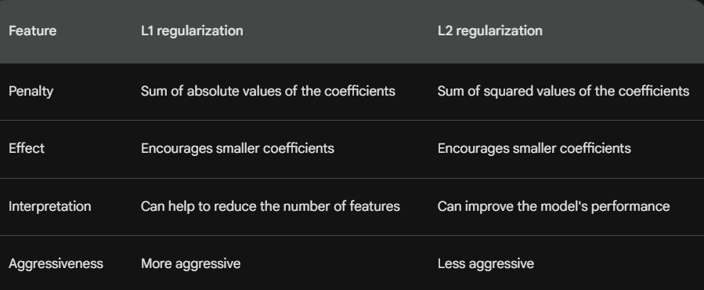

1. Explain the concept of ridge regression and its role in regularization.

Ans:- Ridge regression is a type of linear regression that adds a penalty to the sum of the squared values of the model coefficients. This penalty is called the **ridge penalty**. The ridge penalty encourages the model coefficients to be smaller, which makes the model less complex.

Ridge regression is a regularization technique. Regularization techniques are used to prevent machine learning models from overfitting the training data. Overfitting occurs when a model learns the training data too well and is unable to generalize to new data. The ridge penalty helps to prevent overfitting by discouraging the model from fitting the noise in the training data.

The ridge penalty is often denoted by the Greek letter *λ*. The value of *λ* controls the strength of the penalty. A larger value of *λ* will result in smaller model coefficients, while a smaller value of *λ* will result in larger model coefficients.

Loss=*i*=1∑*n*​(*yi*​−*y*^​*i*​)2+*λj*=1∑*p*​*βj*2​

where:

* *yi*​ is the observed value for the $i$th data point
* *y*^​*i*​ is the predicted value for the $i$th data point
* *βj*​ is the $j$th model coefficient
* *n* is the number of data points
* *p* is the number of features

The ridge regression model can be solved using a variety of optimization algorithms, such as gradient descent.

the benefits of using ridge regression:

* Prevents overfitting: Ridge regression helps to prevent machine learning models from overfitting the training data. This makes the models more generalizable to new data.
* Improves model performance: Ridge regression can improve the performance of machine learning models on both the training data and the test data.
* Makes models more interpretable: Ridge regression can make machine learning models more interpretable by reducing the complexity of the models.

However, ridge regression also has some limitations:

* Can reduce model accuracy: In some cases, ridge regression can reduce the accuracy of machine learning models. This is because ridge regression can prevent the models from learning the training data as well.
* Can be difficult to tune: The hyperparameter *λ* can be difficult to tune. This can make it difficult to find the right balance between preventing overfitting and reducing model accuracy.

1. What is the elastic net regularization and how does it combine L1 and L2 penalties?

Ans:- :-Elastic net regularization is a regularization technique that combines L1 and L2 penalties. L1 regularization adds a penalty to the sum of the absolute values of the model coefficients, while L2 regularization adds a penalty to the sum of the squared values of the model coefficients. Elastic net regularization combines these two penalties, which can help to improve the performance of machine learning models.

The elastic net penalty is often denoted by the Greek letter *α*. The value of *α* controls the relative weight of the L1 and L2 penalties. A larger value of *α* will give more weight to the L1 penalty, while a smaller value of *α* will give more weight to the L2 penalty.

The elastic net model is trained by minimizing the following loss function:

Loss=*i*=1∑*n*​(*yi*​−*y*^​*i*​)2+*αj*=1∑*p*​(*βj*2​+*λ*∣*βj*​∣)

where:

* *yi*​ is the observed value for the $i$th data point
* *y*^​*i*​ is the predicted value for the $i$th data point
* *βj*​ is the $j$th model coefficient
* *n* is the number of data points
* *p* is the number of features
* *α* is the weight of the L1 penalty
* *λ* is the weight of the L2 penalty

The elastic net model can be solved using a variety of optimization algorithms, such as gradient descent.

Elastic net regularization is a powerful regularization technique that can be used to improve the performance of machine learning models. It is especially useful for models that are trained on small datasets or models that are prone to overfitting.

the benefits of using elastic net regularization:

* Prevents overfitting: Elastic net regularization helps to prevent machine learning models from overfitting the training data. This makes the models more generalizable to new data.
* Improves model performance: Elastic net regularization can improve the performance of machine learning models on both the training data and the test data.
* Makes models more interpretable: Elastic net regularization can make machine learning models more interpretable by reducing the complexity of the models.

However, elastic net regularization also has some limitations:

* Can reduce model accuracy: In some cases, elastic net regularization can reduce the accuracy of machine learning models. This is because elastic net regularization can prevent the models from learning the training data as well.
* Can be difficult to tune: The hyperparameters *α* and *λ* can be difficult to tune. This can make it difficult to find the right balance between preventing overfitting and reducing model accuracy.

1. How does regularization help prevent overfitting in machine learning models?

Ans:- **Overfitting** occurs when a machine learning model learns the training data too well and is unable to generalize to new data. This can happen when the model is too complex or when the training data is not representative of the real world.

**Regularization** is a technique that can be used to prevent overfitting by adding a penalty to the loss function. This penalty discourages the model from becoming too complex, which can help to prevent the model from fitting the noise in the training data.

1. What is early stopping and how does it relate to regularization?

Ans:- **Early stopping** is a technique that can be used to prevent overfitting in machine learning models. It works by stopping the training process early, before the model has had a chance to overfit the training data.

**Regularization** is a technique that can also be used to prevent overfitting. It works by adding a penalty to the loss function that discourages the model from becoming too complex.

1. Explain the concept of dropout regularization in neural networks.

Ans:- **Dropout regularization** is a technique for preventing neural networks from overfitting. It works by randomly dropping out (i.e., setting to zero) a certain percentage of the neurons during training. This forces the neural network to learn to rely on other neurons to make predictions, which helps to prevent the network from becoming too dependent on any one neuron.

Dropout regularization is a powerful technique for preventing neural networks from overfitting. It is easy to implement and can be used with any type of neural network.

1. How do you choose the regularization parameter in a model?

Ans:- There are a few different ways to choose the regularization parameter in a model. One common approach is to use **cross-validation**. Cross-validation is a technique for evaluating the performance of a model on unseen data. It works by dividing the training data into a number of folds, and then training the model on a subset of the folds and testing it on the remaining folds.

To choose the regularization parameter, you can train the model with different values of the regularization parameter and then use cross-validation to evaluate the performance of the model on the test folds. The regularization parameter that results in the best performance on the test folds is the best choice for the regularization parameter.

1. What is the difference between feature selection and regularization?

Ans:- **Feature selection** and **regularization** are two techniques used to prevent overfitting in machine learning models. However, they work in different ways.

Feature selection involves selecting a subset of the features in the dataset that are most relevant to the target variable. This can be done using a variety of techniques, such as **correlation**, **information gain**, and **backward elimination**.

Regularization, on the other hand, involves adding a penalty to the loss function that discourages the model from becoming too complex. This can be done using techniques such as **L1** and **L2** regularization.

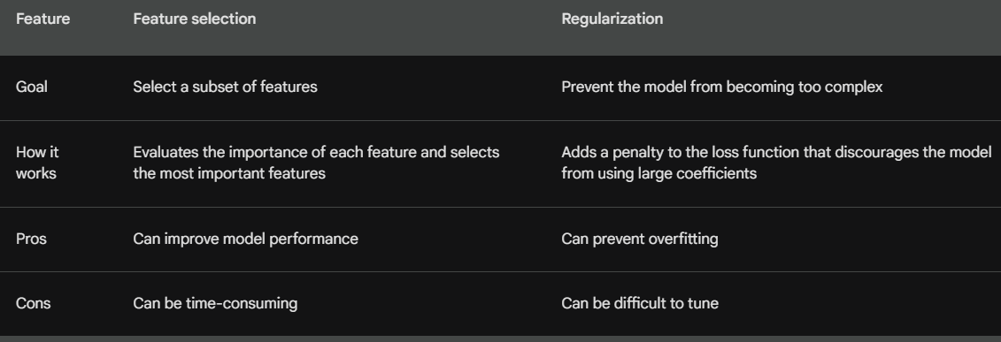

1. What is the trade-off between bias and variance in regularized models?

Ans:- **Bias** and **variance** are two important concepts in machine learning. **Bias** refers to the difference between the expected value of the model's predictions and the true value of the target variable. **Variance** refers to the variability of the model's predictions around the expected value.

In regularized models, there is a trade-off between bias and variance. **A model with high bias** will have low variance, but it will also have low accuracy. This is because the model will be too simple and will not be able to capture the nuances of the data. **A model with high variance** will have high accuracy, but it will also have high variance. This is because the model will be too complex and will be sensitive to noise in the data.

The goal of regularization is to find a model that minimizes the **bias-variance tradeoff**. This means finding a model that has both low bias and low variance.

* L1 regularization penalizes the absolute values of the model coefficients. This encourages the model to have fewer coefficients, which can help to reduce bias.
* L2 regularization penalizes the squared values of the model coefficients. This encourages the model to have smaller coefficients, which can help to reduce variance.

SVM:

1. What is Support Vector Machines (SVM) and how does it work?

Ans:- **Support Vector Machines** (SVM) are a type of **supervised learning** algorithm that can be used for **classification** and **regression** tasks. SVMs work by finding the **hyperplane** that best separates the two classes of data. The hyperplane is a line or plane that divides the data into two regions, with all the data points of one class on one side of the hyperplane and all the data points of the other class on the other side.

The SVM algorithm finds the hyperplane that maximizes the **margin** between the two classes. The margin is the distance between the hyperplane and the nearest data points of each class. The larger the margin, the better the SVM model will generalize to new data.

the benefits of using SVMs:

* High accuracy: SVMs can achieve high accuracy on a variety of tasks.
* Robust to noise: SVMs are relatively robust to noise in the data.
* Interpretable: SVM models can be interpreted, which can be helpful for understanding the results of the model.

However, SVMs also have some limitations:

* Computationally expensive: SVMs can be computationally expensive to train, especially for large datasets.
* Not suitable for all tasks: SVMs are not suitable for all tasks. They are not as good as other algorithms for tasks where the classes are not well-separated.

1. How does the kernel trick work in SVM?

Ans:- The **kernel trick** is a technique that allows SVMs to be used for **non-linear** classification tasks. In a nutshell, the kernel trick transforms the data into a higher-dimensional space where the classes are linearly separable. This allows SVMs to find a hyperplane that separates the two classes in the higher-dimensional space, which can then be used to classify new data points in the original space.

1. What are support vectors in SVM and why are they important?

Ans:- **Support vectors** are the data points that are closest to the hyperplane in **Support Vector Machines** (SVM). The support vectors are important because they determine the position of the hyperplane.

The SVM algorithm finds the hyperplane that maximizes the margin between the two classes. The margin is the distance between the hyperplane and the nearest data points of each class. The larger the margin, the better the SVM model will generalize to new data.

1. Explain the concept of the margin in SVM and its impact on model performance?

Ans:-The margin in Support Vector Machines (SVM) is the distance between the hyperplane and the nearest data points of each class. The larger the margin, the better the SVM model will generalize to new data.

The SVM algorithm finds the hyperplane that maximizes the margin between the two classes. This means that the hyperplane will be as far away as possible from the nearest data points of each class.

The margin is important for model performance because it measures how well the model is able to separate the two classes. A larger margin means that the model is more confident in its predictions, and it is less likely to misclassify new data points.

Here are some of the benefits of using a large margin:

* Better generalization: A larger margin means that the model is more likely to generalize well to new data. This is because the model is not as sensitive to noise in the data.
* More robust to outliers: A larger margin means that the model is more robust to outliers. This is because the outliers will be further away from the hyperplane, and they will have less impact on the model's predictions.

However, there are also some drawbacks to using a large margin:

* Less accurate: A larger margin may lead to less accurate predictions, especially if the data is not linearly separable.
* More computationally expensive: Finding the hyperplane with the largest margin can be more computationally expensive than finding the hyperplane that simply separates the two classes

1. How do you handle unbalanced datasets in SVM?

* Ans:-Cost-sensitive learning: Cost-sensitive learning is a technique that assigns different costs to misclassifications of different classes. This allows the SVM algorithm to focus on misclassifications of the minority class, which can help to improve the performance of the model on unbalanced datasets.
* Class weighting: Class weighting is a technique that assigns different weights to the classes in the loss function. This allows the SVM algorithm to give more importance to the minority class, which can help to improve the performance of the model on unbalanced datasets.
* Data sampling: Data sampling is a technique that oversamples the minority class or undersamples the majority class. This can help to balance the dataset, which can improve the performance of the SVM algorithm.

1. What is the difference between linear SVM and non-linear SVM?

Ans:- **Linear SVM** is a type of **Support Vector Machine** (SVM) that uses a **linear hyperplane** to separate the two classes of data. A linear hyperplane is a line or plane that divides the data into two regions, with all the data points of one class on one side of the hyperplane and all the data points of the other class on the other side.

**Non-linear SVM** is a type of SVM that uses a **non-linear hyperplane** to separate the two classes of data. A non-linear hyperplane is a line or plane that does not divide the data into two regions in a linear fashion.

The main difference between linear SVM and non-linear SVM is that linear SVM can only be used for **linearly separable** data, while non-linear SVM can be used for **non-linearly separable** data.

1. What is the role of C-parameter in SVM and how does it affect the decision boundary?

Ans:-C is a hyperparameter in Support Vector Machines (SVM) that controls the trade-off between fitting the training data and avoiding overfitting. A higher C value means that the model will try to fit the training data more closely, while a lower C value means that the model will be more likely to avoid overfitting.

The decision boundary is the line or plane that separates the two classes of data in SVM. The C parameter affects the decision boundary in two ways:

* A higher C value will result in a tighter decision boundary. This means that the model will try to fit the training data more closely, which can lead to overfitting.
* A lower C value will result in a looser decision boundary. This means that the model will be more likely to avoid overfitting, but it may also lead to a less accurate model.

1. Explain the concept of slack variables in SVM.

Ans:- **Slack variables** are used in **Support Vector Machines** (SVM) to deal with **non-separable** data. In SVM, the goal is to find a **hyperplane** that separates the two classes of data. However, if the data is not linearly separable, then there may not be a hyperplane that can perfectly separate the two classes. In this case, slack variables are used to allow some data points to be misclassified.

1. What is the difference between hard margin and soft margin in SVM?

Ans:- **Hard margin** and **soft margin** are two different approaches to **Support Vector Machines** (SVM). Hard margin SVM tries to find a **hyperplane** that perfectly separates the two classes of data, while soft margin SVM allows some data points to be misclassified.

**Hard margin SVM** is a **linear classifier** that tries to find a hyperplane that separates the two classes of data with **zero errors**. This means that all the data points must be on the correct side of the hyperplane. If there are any data points that are on the wrong side of the hyperplane, then the SVM model will not be able to learn.

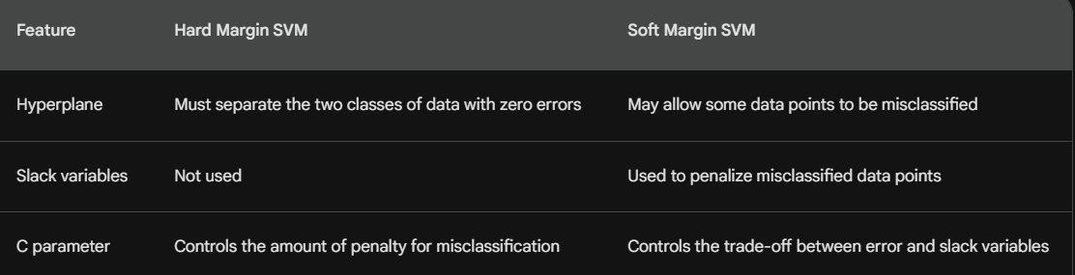

1. How do you interpret the coefficients in an SVM model?

Ans:- Support Vector Machines (SVM), the coefficients are used to calculate the **decision function**. The decision function is a mathematical expression that is used to classify new data points.

The coefficients are also used to determine the **importance** of each feature. The feature with the largest coefficient is the most important feature, and the feature with the smallest coefficient is the least important feature.

Sure, here is an explanation on how to interpret the coefficients in an SVM model:

In Support Vector Machines (SVM), the coefficients are used to calculate the decision function. The decision function is a mathematical expression that is used to classify new data points.

The coefficients are also used to determine the importance of each feature. The feature with the largest coefficient is the most important feature, and the feature with the smallest coefficient is the least important feature.

Here is an example of how to interpret the coefficients in an SVM model:

Let's say we have a dataset of two classes of data, red and blue. We want to use an SVM model to classify new data points as red or blue.

The SVM model has the following coefficients:

* Feature 1: 3
* Feature 2: -2

This means that feature 1 is more important than feature 2 for classifying new data points. A new data point with a high value for feature 1 is more likely to be classified as red, while a new data point with a high value for feature 2 is more likely to be classified as blue.

The coefficients in an SVM model can also be used to visualize the decision boundary. The decision boundary is the line or plane that separates the two classes of data.

The decision boundary can be visualized by plotting the coefficients for each feature. The points with the highest coefficients will be closest to the decision boundary.

Decision Trees:

1. What is a decision tree and how does it work?

Ans:- **decision tree** is a **supervised learning** algorithm that can be used for **classification** and **regression** tasks. Decision trees work by breaking down the data into smaller and smaller subsets, until each subset can be classified or predicted.

A decision tree is a **tree-like** structure that consists of **nodes** and **branches**. The nodes represent **decisions**, and the branches represent the **outcomes** of those decisions. The decision tree is **trained** by **traversing** the tree and **assigning** labels to the leaf nodes.

The decision tree is **used** to **classify** new data points by **traversing** the tree and **following** the branches until a leaf node is reached. The label of the leaf node is then used to classify the new data point.

Root Node: Is the email from a known sender?

* Yes: Not spam

* No: Continue

* Is the email from a university?

* Yes: Not spam

* No: Spam

Decision trees are a **powerful** and **easy-to-understand** machine learning algorithm. They are **relatively** **fast** to train, and they can be used for a variety of tasks.

1. How do you make splits in a decision tree?

Ans:- Decision trees are made up of nodes and branches. The nodes represent decisions, and the branches represent the outcomes of those decisions. The decision tree is trained by traversing the tree and assigning labels to the leaf nodes.

The decision tree is used to classify new data points by traversing the tree and following the branches until a leaf node is reached. The label of the leaf node is then used to classify the new data point.

The splitting process in a decision tree is recursive. The algorithm starts at the root node and tries to find the best split for that node. The best split is the one that minimizes the **information gain**.

The information gain is a measure of how much information is gained by splitting the data at a particular node. The higher the information gain, the better the split.

the factors that are considered when making splits in a decision tree:

* Information gain: The information gain is a measure of how much information is gained by splitting the data at a particular node.
* Gini impurity: The Gini impurity is a measure of how mixed the data is at a particular node.
* Variance: The variance is a measure of how spread out the data is at a particular node.

1. What are impurity measures (e.g., Gini index, entropy) and how are they used in decision trees?

Ans:- **I**mpurity measures are used in decision trees to evaluate the quality of a split. A split is a decision that divides the data into two or more groups. The goal of a decision tree is to find the best split, which is the split that minimizes the impurity of the data.

There are two common impurity measures used in decision trees:

* Gini impurity: The Gini impurity is a measure of how mixed the data is at a particular node. The lower the Gini impurity, the more pure the data is.
* Entropy: Entropy is a measure of how uncertain the data is at a particular node. The lower the entropy, the more certain the data is.

1. Explain the concept of information gain in decision trees.

Ans:- Information gain is a measure of how much information is gained by splitting the data at a particular node. The higher the information gain, the better the split.

In decision trees, information gain is used to evaluate the quality of a split. A split is a decision that divides the data into two or more groups. The goal of a decision tree is to find the best split, which is the split that minimizes the impurity of the data.

Information Gain = H(Parent) - H(Children)

where:

* H(Parent) is the entropy of the parent node
* H(Children) is the weighted average of the entropies of the child nodes

The entropy of a node is a measure of how uncertain the data is at that node. The lower the entropy, the more certain the data is.

The information gain is a measure of how much uncertainty is reduced by splitting the data. The higher the information gain, the more uncertainty is reduced by splitting the data.

1. How do you handle missing values in decision trees?

Ans:- he ways to handle missing values in decision trees:

* Ignore the missing values: This is the simplest way to handle missing values. The algorithm will simply ignore any data points that have missing values. However, this can lead to a loss of information and can make the decision tree less accurate.
* Impute the missing values: This involves replacing the missing values with some other value. There are a number of different imputation methods that can be used, such as mean imputation, median imputation, and mode imputation.
* Use a decision tree algorithm that can handle missing values: There are a number of decision tree algorithms that can handle missing values. These algorithms will typically use a technique called recursive partitioning to deal with missing values. Recursive partitioning involves splitting the data into smaller and smaller subsets, until each subset contains no missing values.

the pros and cons of each method:

* Ignoring the missing values:
  + Pros: This is the simplest method to implement.
  + Cons: This can lead to a loss of information and can make the decision tree less accurate.
* Imputing the missing values:
  + Pros: This can help to reduce the loss of information and can make the decision tree more accurate.
  + Cons: The imputation method that is used can affect the accuracy of the decision tree.
* Using a decision tree algorithm that can handle missing values:
  + Pros: This can be a good option if the missing values are a significant part of the dataset.
  + Cons: These algorithms can be more complex to implement.

1. What is pruning in decision trees and why is it important?

Ans:- **Pruning** in decision trees is a technique used to reduce the size of a decision tree. Pruning can improve the **accuracy** of a decision tree by removing **unnecessary** branches.

Decision trees are typically grown to be as large as possible. This is because the larger the tree, the more information it can capture about the data. However, larger trees can also be more **complex** and **prone to overfitting**.

Pruning can help to reduce the complexity of a decision tree by removing unnecessary branches. This can help to improve the accuracy of the tree by preventing it from overfitting the data.

**Pre-pruning** is performed before the decision tree is fully grown. The algorithm will stop growing the tree at a certain point, based on a **stopping criterion**.

**Post-pruning** is performed after the decision tree is fully grown. The algorithm will remove branches from the tree that are not **statistically significant**.

the benefits of pruning decision trees:

* Improves accuracy: Pruning can improve the accuracy of a decision tree by removing unnecessary branches.
* Reduces complexity: Pruning can reduce the complexity of a decision tree, which can make it easier to understand and interpret.
* Prevents overfitting: Pruning can help to prevent a decision tree from overfitting the data, which can improve its accuracy on new data.

However, there are also some drawbacks to pruning decision trees:

* Can reduce accuracy: Pruning can sometimes reduce the accuracy of a decision tree, especially if the tree is not very complex.
* Can be time-consuming: Pruning can be time-consuming, especially if the tree is large.

1. What is the difference between a classification tree and a regression tree?

Ans;- A **classification tree** is a decision tree that is used to **classify** data into two or more categories. A **regression tree** is a decision tree that is used to **predict** a continuous value.

The main difference between a classification tree and a regression tree is the **target variable**. The target variable in a classification tree is a categorical variable, such as "red" or "blue". The target variable in a regression tree is a continuous variable, such as "price" or "weight".

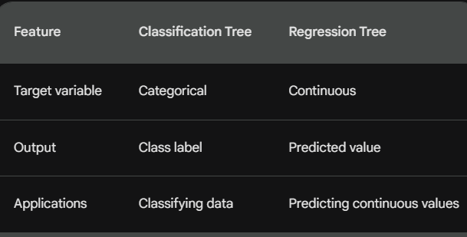

the benefits of using classification trees:

* Easy to understand: Classification trees are easy to understand, which makes them a good choice for explainability.
* Relatively fast to train: Classification trees are relatively fast to train, which makes them a good choice for large datasets.
* Versatile: Classification trees can be used for a variety of tasks, including classification and regression.

However, there are also some drawbacks to using classification trees:

* Not as accurate as other algorithms: Classification trees are not as accurate as some other machine learning algorithms, such as Support Vector Machines (SVM).
* Sensitive to noise: Classification trees can be sensitive to noise in the data, which can lead to overfitting.

1. How do you interpret the decision boundaries in a decision tree?

Ans:- A decision tree is a **supervised learning** algorithm that can be used for **classification** and **regression** tasks. Decision trees work by breaking down the data into smaller and smaller subsets, until each subset can be classified or predicted.

The decision tree is **trained** by **traversing** the tree and **assigning** labels to the leaf nodes.

The decision tree is **used** to **classify** new data points by **traversing** the tree and **following** the branches until a leaf node is reached. The label of the leaf node is then used to classify the new data point.

The decision boundaries in a decision tree are the **lines** that separate the different classes of data. The decision boundaries are determined by the **splits** in the tree.

the benefits of interpreting decision boundaries:

* Understanding how the tree is making decisions: By understanding the decision boundaries, you can understand how the tree is making decisions. This can help you to identify the features that are most important for making predictions.
* Visualizing the data: The decision boundaries can be used to visualize the data. This can help you to see how the different features are related to the target variable.
* Improving the tree: By understanding the decision boundaries, you can identify areas where the tree can be improved. This can help you to improve the accuracy of the tree.

However, there are also some drawbacks to interpreting decision boundaries:

* Can be difficult to interpret: The decision boundaries can be difficult to interpret, especially if the tree is complex.
* Can be misleading: The decision boundaries can be misleading, if the tree is not well-trained.

1. What is the role of feature importance in decision trees?

Ans:- Feature importance is a measure of how important a feature is for making predictions in a decision tree. Feature importance is calculated by measuring how much the impurity of the data is reduced when a feature is used to split the data.

The impurity of the data is a measure of how mixed the data is. The lower the impurity, the more pure the data is.

The decision tree algorithm will try to find the best split, which is the split that minimizes the impurity of the data. The best split is the one that creates two child nodes with the lowest impurity.

The feature importance of a feature is calculated by measuring the decrease in impurity that is caused by splitting the data on that feature. The higher the decrease in impurity, the more important the feature is for making predictions.

Feature importance can be used to understand how a decision tree is making predictions. It can also be used to select the most important features for a decision tree model.

Here are some of the benefits of using feature importance:

* Understanding how a decision tree is making predictions: By understanding the feature importance, you can understand how the decision tree is making predictions. This can help you to identify the features that are most important for making predictions.
* Selecting the most important features: Feature importance can be used to select the most important features for a decision tree model. This can help you to improve the accuracy of the model.

However, there are also some drawbacks to using feature importance:

* Can be misleading: Feature importance can be misleading, if the tree is not well-trained.
* Not always accurate: Feature importance is not always accurate. The importance of a feature can change depending on the dataset and the decision tree algorithm that is used.

Overall, feature importance can be a helpful tool for understanding how a decision tree is making predictions and for selecting the most important features for a decision tree model. However, it is important to be aware of the limitations of using feature importance.

1. What are ensemble techniques and how are they related to decision trees?

Ans:-Ensemble techniques are a type of machine learning algorithm that combines multiple models to improve the overall performance of the model. Decision trees are a popular type of model that can be used in ensemble techniques.

There are many different ensemble techniques, but some of the most common include:

* Bagging: Bagging is a technique that creates multiple copies of a model and trains each copy on a different subset of the data. The predictions from the different models are then combined to make a final prediction.
* Boosting: Boosting is a technique that creates multiple models in sequence. Each model is trained to correct the errors of the previous model. The predictions from the different models are then combined to make a final prediction.
* Random Forest: Random forest is a type of ensemble technique that combines multiple decision trees. Each decision tree is trained on a different subset of the data and with a different subset of the features. The predictions from the different decision trees are then combined to make a final prediction.

the benefits of using ensemble techniques with decision trees:

* Improved accuracy: Ensemble techniques can improve the accuracy of decision trees by reducing variance.
* Reduced overfitting: Ensemble techniques can help to reduce overfitting, which can improve the generalization performance of the model.
* More robust: Ensemble techniques are more robust to noise in the data than individual decision trees.

However, there are also some drawbacks to using ensemble techniques with decision trees:

* Can be computationally expensive: Ensemble techniques can be computationally expensive to train, especially if a large number of models are used.
* Can be difficult to interpret: Ensemble techniques can be difficult to interpret, especially if a large number of models are used.

Overall, ensemble techniques can be a powerful way to improve the accuracy and robustness of decision trees. However, it is important to be aware of the limitations of ensemble techniques before using them.

Ensemble Techniques:

1. What are ensemble techniques in machine learning?

Ans:- Ensemble techniques, also known as ensemble learning, are a type of machine learning algorithm that combines multiple models to improve the overall performance of the model. Ensemble techniques are often used to improve the accuracy, robustness, or efficiency of a machine learning model.

There are many different ensemble techniques, but some of the most common include:

* Bagging: Bagging is a technique that creates multiple copies of a model and trains each copy on a different subset of the data. The predictions from the different models are then combined to make a final prediction.
* Boosting: Boosting is a technique that creates multiple models in sequence. Each model is trained to correct the errors of the previous model. The predictions from the different models are then combined to make a final prediction.
* Random forest: Random forest is a type of ensemble technique that combines multiple decision trees. Each decision tree is trained on a different subset of the data and with a different subset of the features. The predictions from the different decision trees are then combined to make a final prediction.

the benefits of using ensemble techniques in machine learning:

* Improved accuracy: Ensemble techniques can improve the accuracy of machine learning models by reducing variance.
* Reduced overfitting: Ensemble techniques can help to reduce overfitting, which can improve the generalization performance of the model.
* More robust: Ensemble techniques are more robust to noise in the data than individual models.
* Efficiency: Ensemble techniques can be more efficient than training a single model, especially if the individual models are simple.

However, there are also some drawbacks to using ensemble techniques in machine learning:

* Can be computationally expensive: Ensemble techniques can be computationally expensive to train, especially if a large number of models are used.
* Can be difficult to interpret: Ensemble techniques can be difficult to interpret, especially if a large number of models are used.

Overall, ensemble techniques can be a powerful way to improve the accuracy and robustness of machine learning models. However, it is important to be aware of the limitations of ensemble techniques before using them.

1. What is bagging and how is it used in ensemble learning?

Ans:- Bagging is a type of ensemble learning that combines multiple models to improve the overall accuracy of the model. Bagging stands for bootstrap aggregating.

In bagging, multiple copies of a model are created and each copy is trained on a different subset of the data. The predictions from the different models are then combined to make a final prediction.

Bagging can be used with any type of machine learning model, but it is most commonly used with decision trees. This is because decision trees are relatively easy to train and they can be used to capture complex relationships between the features and the target variable.

Bagging works by reducing variance. Variance is a measure of how much the predictions of a model vary from one data point to another. High variance can lead to overfitting, which is when a model learns the training data too well and does not generalize well to new data.

Bagging reduces variance by training multiple models on different subsets of the data. This helps to average out the errors of the individual models and produce a more accurate prediction.

Here are some of the benefits of using bagging:

* Improved accuracy: Bagging can improve the accuracy of machine learning models by reducing variance.
* Reduced overfitting: Bagging can help to reduce overfitting, which can improve the generalization performance of the model.
* More robust: Bagging is more robust to noise in the data than individual models.

However, there are also some drawbacks to using bagging:

* Can be computationally expensive: Bagging can be computationally expensive to train, especially if a large number of models are used.
* Can be difficult to interpret: Bagging can be difficult to interpret, especially if a large number of models are used.

Overall, bagging can be a powerful way to improve the accuracy and robustness of machine learning models. However, it is important to be aware of the limitations of bagging before using it.

Here are some of the steps involved in bagging:

1. Randomly sample the data with replacement. This means that some data points may be selected more than once, while other data points may not be selected at all.
2. Train a model on each of the bootstrap samples.
3. Combine the predictions from the different models to make a final prediction.

The following are some of the most common bagging algorithms:

* Random forest: Random forest is a type of ensemble technique that combines multiple decision trees. Each decision tree is trained on a different subset of the data and with a different subset of the features. The predictions from the different decision trees are then combined to make a final prediction.
* Extra trees: Extra trees is a type of ensemble technique that is similar to random forest. However, extra trees uses a different algorithm to train the decision trees. This algorithm is more efficient than the algorithm used in random forest, but it can also be less accurate.
* AdaBoost: AdaBoost is a type of ensemble technique that creates multiple models in sequence. Each model is trained to correct the errors of the previous model. The predictions from the different models are then combined to make a final prediction.

1. Explain the concept of bootstrapping in bagging?

Ans:- **Bootstrapping** is a statistical technique that involves sampling data with replacement. This means that some data points may be selected more than once, while other data points may not be selected at all.

Bootstrapping is used in bagging to create multiple copies of the training data. Each copy is called a **bootstrap sample**. The bootstrap samples are then used to train different models.

The use of bootstrapping in bagging helps to reduce **variance** in the models. Variance is a measure of how much the predictions of a model vary from one data point to another. High variance can lead to overfitting, which is when a model learns the training data too well and does not generalize well to new data.

the benefits of using bootstrapping in bagging:

* Reduced variance: Bootstrapping can help to reduce variance in the models, which can improve the generalization performance of the model.
* More robust: Bootstrapping can make the model more robust to noise in the data.

However, there are also some drawbacks to using bootstrapping in bagging:

* Can be computationally expensive: Bootstrapping can be computationally expensive to train, especially if a large number of bootstrap samples are used.
* Can be difficult to interpret: Bootstrapping can be difficult to interpret, especially if a large number of bootstrap samples are used.

Overall, bootstrapping can be a powerful way to improve the accuracy and robustness of machine learning models. However, it is important to be aware of the limitations of bootstrapping before using it.

1. What is boosting and how does it work?

Ans:- **Boosting** is a type of ensemble learning that combines multiple models to improve the overall **accuracy** of the model. Boosting is a sequential process, where each model is trained to correct the errors of the previous model.

The most common type of boosting is **AdaBoost** (Adaptive Boosting). AdaBoost works by training a series of weak learners, each of which is trained to focus on the data points that were misclassified by the previous learner. The predictions from the different learners are then combined to make a final prediction.

Boosting works by **reducing bias**. Bias is a measure of how far away the predictions of a model are from the true values. High bias can lead to underfitting, which is when a model does not learn the training data well enough.

Boosting reduces bias by training a series of weak learners. Weak learners are models that are not very accurate on their own. However, when the predictions of the weak learners are combined, they can produce a more accurate model.

the benefits of using boosting:

* Improved accuracy: Boosting can improve the accuracy of machine learning models by reducing bias.
* Reduced underfitting: Boosting can help to reduce underfitting, which can improve the generalization performance of the model.
* More robust: Boosting is more robust to noise in the data than individual models.

However, there are also some drawbacks to using boosting:

* Can be computationally expensive: Boosting can be computationally expensive to train, especially if a large number of weak learners are used.
* Can be difficult to interpret: Boosting can be difficult to interpret, especially if a large number of weak learners are used.

Overall, boosting can be a powerful way to improve the accuracy and robustness of machine learning models. However, it is important to be aware of the limitations of boosting before using it.

Here are some of the steps involved in boosting:

1. Initialize the weights of the data points. The weights are typically initialized to be equal.
2. Train a weak learner and make predictions on the data.
3. Calculate the error of the weak learner. The error is the difference between the predictions of the weak learner and the true values.
4. Update the weights of the data points. The weights of the data points that were misclassified by the weak learner are increased.
5. Repeat steps 2-4 until the desired number of weak learners have been trained.
6. Combine the predictions of the weak learners to make a final prediction.

The following are some of the most common boosting algorithms:

* AdaBoost: AdaBoost is a type of boosting that works by training a series of weak learners, each of which is trained to focus on the data points that were misclassified by the previous learner.
* XGBoost: XGBoost is a type of boosting that is based on gradient boosting. Gradient boosting is a more efficient way to train boosting models than AdaBoost.
* CatBoost: CatBoost is a type of boosting that is specifically designed for categorical data. CatBoost uses a technique called category boosting to train models that are more accurate on categorical data.

1. What is the difference between AdaBoost and Gradient Boosting?

* Ans:-AdaBoost (Adaptive Boosting) is a type of boosting that works by training a series of weak learners, each of which is trained to focus on the data points that were misclassified by the previous learner. The predictions from the different learners are then combined to make a final prediction.
* Gradient Boosting is a type of boosting that is based on gradient descent. Gradient descent is an optimization algorithm that is used to find the minimum of a function. In the context of boosting, gradient descent is used to find the weights of the weak learners that minimize the error of the model.

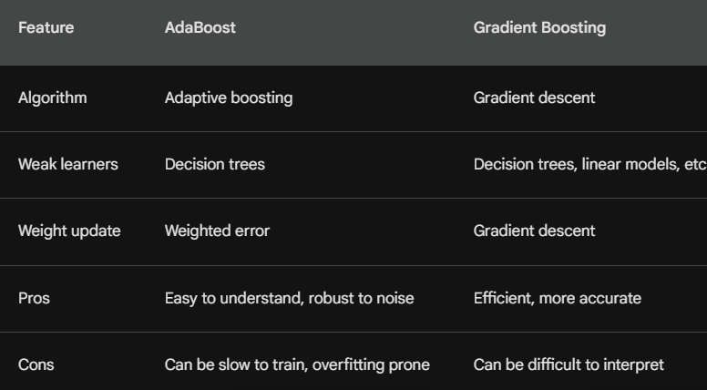

1. What is the purpose of random forests in ensemble learning?

Ans:- **Random forests** are a type of ensemble learning algorithm that combines multiple decision trees. Each decision tree is trained on a different subset of the data and with a different subset of the features. The predictions from the different decision trees are then combined to make a final prediction.

Random forests are used in ensemble learning to improve the accuracy and robustness of machine learning models.

* Accuracy: Random forests can improve the accuracy of machine learning models by reducing variance. Variance is a measure of how much the predictions of a model vary from one data point to another. High variance can lead to overfitting, which is when a model learns the training data too well and does not generalize well to new data.
* Robustness: Random forests are also more robust to noise in the data than individual decision trees. This is because each decision tree is trained on a different subset of the data, which helps to average out the noise in the data.

Here are some of the steps involved in random forests:

1. Randomly sample the data with replacement. This means that some data points may be selected more than once, while other data points may not be selected at all.
2. Train a decision tree on each of the bootstrap samples.
3. Combine the predictions from the different decision trees to make a final prediction.

The following are some of the benefits of using random forests:

* Improved accuracy: Random forests can improve the accuracy of machine learning models by reducing variance.
* Reduced overfitting: Random forests can help to reduce overfitting, which can improve the generalization performance of the model.
* More robust: Random forests are more robust to noise in the data than individual decision trees.
* Efficiency: Random forests can be trained efficiently, even on large datasets.

However, there are also some drawbacks to using random forests:

* Can be difficult to interpret: Random forests can be difficult to interpret, especially if a large number of decision trees are used.

Overall, random forests are a powerful tool that can be used to improve the accuracy and robustness of machine learning models. However, it is important to be aware of the limitations of random forests before using them.

1. How do random forests handle feature importance?

Ans:- **Feature importance** is a measure of how important a feature is for making predictions in a machine learning model. Feature importance can be used to understand how a model is making predictions and to select the most important features for a model.

Random forests handle feature importance by measuring the **decrease in impurity** that is caused by splitting the data on a particular feature. The more a feature decreases impurity, the more important it is for making predictions.

the benefits of using feature importance in random forests:

* Understanding how a model is making predictions: Feature importance can be used to understand how a model is making predictions. This can be helpful for identifying the features that are most important for making predictions.
* Selecting the most important features: Feature importance can be used to select the most important features for a model. This can help to improve the accuracy and efficiency of the model.

However, there are also some drawbacks to using feature importance in random forests:

* Can be misleading: Feature importance can be misleading, if the model is not well-trained.
* Not always accurate: Feature importance is not always accurate. The importance of a feature can change depending on the dataset and the random forest algorithm that is used.

Overall, feature importance is a powerful tool that can be used to understand how random forests make predictions and to select the most important features for a random forest model. However, it is important to be aware of the limitations of feature importance before using it.

1. What is stacking in ensemble learning and how does it work?

Ans:- **Stacking** is a type of ensemble learning that combines multiple models to improve the overall **accuracy** of the model. Stacking is a **meta-learning** algorithm, which means that it learns how to combine the predictions of other models.

In stacking, the first step is to train a set of **base models**. These base models can be any type of machine learning model, but they are typically **diverse**. This means that they should have different strengths and weaknesses.

The second step is to train a **meta-model**. The meta-model is trained on the predictions of the base models. The meta-model learns how to combine the predictions of the base models to make a more accurate prediction.

Base Models

Model 1

Model 2

Model 3

Meta Model

Learns how to combine the predictions of the base models

Final Prediction

Stacking can be used to improve the accuracy of machine learning models by reducing bias and variance. Variance is a measure of how much the predictions of a model vary from one data point to another. High variance can lead to overfitting, which is when a model learns the training data too well and does not generalize well to new data.

Stacking can reduce variance by combining the predictions of multiple models. This helps to average out the errors of the individual models and produce a more accurate prediction.

Bias is a measure of how far away the predictions of a model are from the true values. High bias can lead to underfitting, which is when a model does not learn the training data well enough.

Stacking can reduce bias by training a meta-model that learns how to combine the predictions of the base models. The meta-model can learn to focus on the predictions of the base models that are most accurate.

Here are some of the benefits of using stacking:

* Improved accuracy: Stacking can improve the accuracy of machine learning models by reducing bias and variance.
* Reduced overfitting: Stacking can help to reduce overfitting, which can improve the generalization performance of the model.
* More robust: Stacking is more robust to noise in the data than individual models.

However, there are also some drawbacks to using stacking:

* Can be computationally expensive: Stacking can be computationally expensive to train, especially if a large number of base models are used.
* Can be difficult to interpret: Stacking can be difficult to interpret, especially if a large number of base models are used.

Overall, stacking is a powerful tool that can be used to improve the accuracy and robustness of machine learning models. However, it is important to be aware of the limitations of stacking before using it.

1. What are the advantages and disadvantages of ensemble techniques?

Ans:- Ensemble techniques are a type of machine learning algorithm that combines multiple models to improve the overall accuracy of the model. Ensemble techniques have many advantages, including:

* Improved accuracy: Ensemble techniques can improve the accuracy of machine learning models by reducing variance and bias. Variance is a measure of how much the predictions of a model vary from one data point to another. High variance can lead to overfitting, which is when a model learns the training data too well and does not generalize well to new data. Bias is a measure of how far away the predictions of a model are from the true values. High bias can lead to underfitting, which is when a model does not learn the training data well enough.
* Reduced overfitting: Ensemble techniques can help to reduce overfitting, which can improve the generalization performance of the model.
* More robust: Ensemble techniques are more robust to noise in the data than individual models.
* Efficiency: Ensemble techniques can be trained efficiently, even on large datasets.

However, ensemble techniques also have some disadvantages, including:

* Can be computationally expensive: Ensemble techniques can be computationally expensive to train, especially if a large number of models are used.
* Can be difficult to interpret: Ensemble techniques can be difficult to interpret, especially if a large number of models are used.
* Not always better than single models: Ensemble techniques are not always better than single models. In some cases, a single model may be more accurate than an ensemble of models.

Overall, ensemble techniques are a powerful tool that can be used to improve the accuracy and robustness of machine learning models. However, it is important to be aware of the limitations of ensemble techniques before using them.

Here are some of the most common ensemble techniques:

* Bagging: Bagging is a technique that creates multiple copies of a model and trains each copy on a different subset of the data. The predictions from the different models are then combined to make a final prediction.
* Boosting: Boosting is a technique that creates multiple models in sequence. Each model is trained to correct the errors of the previous model. The predictions from the different models are then combined to make a final prediction.
* Random forest: Random forest is a type of ensemble technique that combines multiple decision trees. Each decision tree is trained on a different subset of the data and with a different subset of the features. The predictions from the different decision trees are then combined to make a final prediction.

1. How do you choose the optimal number of models in an ensemble?

Ans:- There is no one-size-fits-all answer to this question, as the optimal number of models in an ensemble will vary depending on the specific problem and the data. However, there are a few general guidelines that can be followed.

One way to choose the optimal number of models is to use a **validation set**. The validation set is a set of data that is held out from the training process and is only used to evaluate the performance of the models. By training a number of different models with different numbers of base models and evaluating their performance on the validation set, you can see how the number of models affects the accuracy of the ensemble.

the optimal number of models in an ensemble:

* The size of the dataset: If the dataset is small, then a smaller number of models may be sufficient.
* The complexity of the problem: If the problem is complex, then a larger number of models may be necessary.
* The computational resources available: Training a large number of models can be computationally expensive.